
Sukkur IBA University
Department of Computer Science
ESE-201: Digital Logic Design Lab

Lab # 02: NAND & NOR Gates
Instructor: Muhammad Ismail Qureshi
Submission Profile
Name: Ghulam Mustafa Submission date 25/12/2025
CMS ID: 023-24-0513 Marks obtained:
Comments: Receiving authority name and signature:

________________________________________________________________________________
Instructor Signature

Note: Submit this lab hand-out on LMS/e-learning before the next lab with attached solved activities and exercises
Lab Learning Objectives:

Upon successful completion of this experiment, the student will be able:
- To implement and verify NAND gate operations using 74LS00 IC & NI ELVIS Kit
- To implement and verify NOR gate operations using 74LS02 IC & NI ELVIS Kit

Lab Hardware and Software Required:
- 74LS00 IC (NAND gate )
- 74LS02 IC(NOR gate)
- NI ELVIS Kit
- Breadboard
- Connecting Wires

Background Theory:

NAND gate:
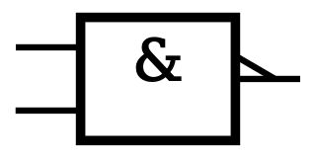
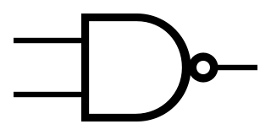
The logic symbols for NAND gate is shown in Fig 2.1 (a & b). It consists of AND symbol with inverter symbol added to output. The operation of NAND gate is same as the AND gate except that its output is inverted. NAND gates can also have two or more than two inputs and a single output. NAND gate produces a LOW output only when all the inputs are HIGH. When any of the inputs is LOW, the output will be HIGH.
A
$$X= \overline{A.B}$$
B
A
B
$$X= \overline{A.B}$$

Fig 2.1: (a) Distinctive symbol of NAND gate (b) Standard NAND gate symbol
74LS00 2-Input NAND gate IC:
In order to implement the NAND gate operation using IC, the TTL 74LS00 2-input NAND gate IC can be used. This IC has 14 pin Dual Inline Package (DIP) configuration as shown in Fig 2.2. The power supply connections are made to pin 7 and 14. Pin 1 is identified by a small indented circle next to it or by a notch cut out between pin 1 and 14.
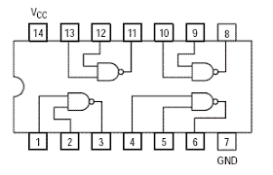

Fig 2.2: 74LS00 2-input NAND gate IC pin configuration
NOR gate:
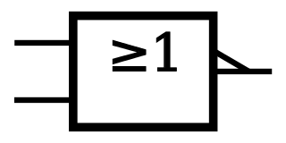

The operation of the NOR gate is same as that of the OR gate except that its output is inverted. You can think of a NOR gate as an OR gate with an inverter at its output. The logic symbol for NOR gate is shown in Fig 2.3 (a & b). NOR gates can also have two or more than two inputs and a single output. The NOR gate produces a low output, When any one of input is high and produces a high output, when all inputs are low.
A
B
$$X= \overline{A+B}$$
A
B
$$X= \overline{A+B}$$

Fig 2.3: (a) Distinctive symbol of 2-input NOR gate (b) Standard 2-input NOR gate symbol
74LS02 2-input NOR gate IC:
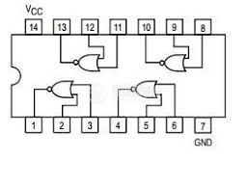
In order to implement the NOR gate operation using IC, the TTL 74LS02 2-input NOR gate IC can be used. This IC has 14 pin Dual Inline Package (DIP) configuration as shown in Fig 2.4. The power supply connections are made to pin 7 and 14. Pin 1 is identified by a small indented circle next to it or by a notch cut out between pin 1 and 14.

Fig 2.4: 74LS02 2-input NOR gate IC pin configuration

Lab Examples:
Implementation of NAND gate
- In order to implement the NAND gate operations with the help of ICs, take the 74LS00
- Pin Assignments for the ICs have been shown in Fig 2.2
- Take 74LS00 IC and insert it in the breadboard present on the NI ELVIS kit
- Connect its pin 14 to +5V and pin 7 to ground
- Use first gate (any one can be taken) from IC by connecting input pin 1 & input pin 2 to SW0 & SW1 respectively, and output pin3to LED and observe the AND gate operation
- Fill the following observation table

Table 2.1: Observation table of NAND gate
Input |  | Output
A | B | LED (on / off) | Level ( 1 / 0 )
0 | 0 | On | 1
0 | 1 | On | 1
1 | 0 | On | 1
1 | 1 | Off | 0
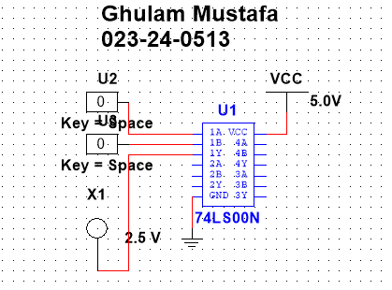

Lab Activities:
Implementation of NOR gate
- In order to implement the AND operations with the help of IC, take the 74LS02 IC
- Pin Assignments for the ICs have been shown in Fig 2.4
- Take 74LS02 IC and insert it in the breadboard present on the NI ELVIS kit
- Connect its pin 14 to +5V and pin 7 to ground
- Use first gate (any one can be taken) from IC by connecting input pin 1 & input pin 2 to SW0 & SW1 respectively, and output pin3to LED and observe the AND gate operation
- Fill the following observation table
Table 2.2: Observation Table of NOR gate
Input |  | Output
A | B | LED (on / off) | Level ( 1 / 0 )
0 | 0 | On | 1
0 | 1 | Off | 0
1 | 0 | Off | 0
1 | 1 | Off | 0
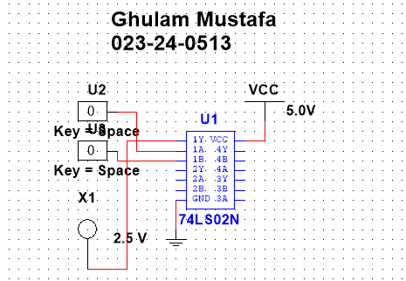

Lab Exercises:
NAND-NOR Universal Gates
NAND and NOR gates are known as Universal Gates as they can be used to construct an AND gate, an OR gate, an INVERTER, or any combination of these functions. The NAND Universal Gate can also be used to implement a NOR gate. Similarly, a NOR gate can be used to implement a NAND gate.
- Implement NAND gate using NOR gates
- Draw the schematic Diagram
- Write the Boolean Expression
- Fill the Observation Table

Schematic Diagram:
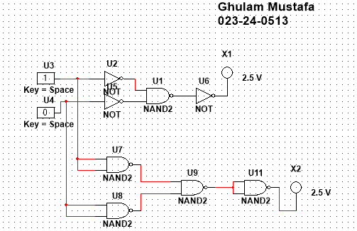

Boolean Expression:
X1=((A’·B’)’)’=(A+B)’
X2=(((A·A)’ · (B·B)’)’)’ =(A+B)’

Table 2.3: Observation table for 2-input NAND gate using NOR gates
Input |  | Output
A | B | LED (on / off) | Level ( 1 / 0 )
0 | 0 | On | 1
0 | 1 | On | 1
1 | 0 | On | 1
1 | 1 | Off | 0

- Implement NOR gate using NAND gates
- Draw the schematic Diagram
- Write the Boolean Expression
- Fill the Observation Table
Schematic Diagram:
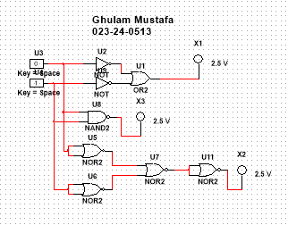

Boolean Expression:
X1=((A’+ B’)’)=(A·B)’
X2=(((A+A)’+(B+B)’)’)’ =(A·B)’

Table 2.4: Observation table for 2-input NOR gate using NAND gates
Input |  | Output
A | B | LED (on / off) | Level ( 1 / 0 )
0 | 0 | On | 1
0 | 1 | Off | 0
1 | 0 | Off | 0
1 | 1 | Off | 0

